Missing Children in the United States
How they went missing, where they were and what they were doing, from public case records. Young adults (18–25) are reported separately in Part 2.
Open NamUs and NCMEC cases on October 25, 2026: 7,571 children and 4,728 young adults
How to read this report
Children and young adults are never pooled. Every figure in Part 1 uses only children: people under 18 for their whole recorded age range. Young adults (18–25) are in Part 2 with their own figures, compared with the population of the same age. 4 records with no age, or an age range that straddles 18, are in neither part. [7]
Open cases only. Counts are cases still listed on October 25, 2026. Since weekly collection began on 2026-10-21, 139 cases have dropped off the listings (found) and are not counted here. [1], [2], [7]

Key findings about children
- Kidnapping by a stranger or other non-family member is rare. It appears in 66 of 7,571 open child cases (1%). National figures agree: NCMEC reports non-family abductions are about 1% of its cases, and FBI records coded “abducted by stranger” were 0.1% in 2023. [7], [6], [3]
- Most missing teenagers left on their own. Over 90% of children reported to NCMEC in 2024 were endangered runaways, and 95.2% of 2023 FBI entries that recorded a reason were coded as runaways. Most come home quickly, so few remain among open cases. [5], [3]
- When the record says how a young child went missing, it is usually a parent who took them. Among children 11 and under, 28% of cases describe a parent or relative taking the child. [7]
- Black, Hispanic and American Indian / Alaska Native children are over-represented. Compared with their share of Americans aged 0 to 17, they appear in open child cases since 2016 at 2.3x, 1.6x and 2.1x their population share (2.3x, 1.4x and 1.9x against the population of the states the cases come from). [7], [8]
- The cases that stay open are the serious ones. Open child runaway cases are typically 3 years old; open non-family abductions and suspected homicides of children, 40 and 41 years. [7]
- Nationally, about 1% of juvenile records make up about half of all active ones. A stock-and-flow model of FBI figures for 2015–2025 finds about 1% of juvenile records clear with a half-life of about 3 years, while the rest close within weeks. [9], [7]
- Most records say very little. 79% of child cases don’t say how the child went missing, and 38% mention any place or activity. [7]

Where the data comes from
Every case comes from one of two official public databases, collected weekly. National context comes from the FBI’s yearly NCIC statistics and NCMEC reports; population figures from the Census Bureau. [1], [2], [9], [8]
Source | What it covers | Link
NamUs (U.S. Dept. of Justice) | Missing people of all ages; filtered to age 25 or under (9,046 cases) | namus.gov
NCMEC (missingkids.org) | Missing children, mostly under 18 | missingkids.org

Group | Open cases | Rule
Children | 7,571 | Under 18 for the whole recorded age range
Young adults | 4,728 | 18–25
Age unknown | 4 | No age, or age range straddles 18 (in neither part)
NCMEC’s search also returns 310 posters for unidentified deceased children; they are excluded because they are not missing-person cases. [2], [7]

Part 1: Children (under 18)

How children went missing
Each case’s written account was checked for words that point to how the child went missing, such as “ran away”, “abducted by her father” or “drowned”. Where NCMEC assigned an official case type, that label was used instead. [7]
How they went missing | Cases | Share
Not stated in the record | 5,999 | 79%
Ran away / left on their own | 579 | 8%
Taken by a parent or relative | 525 | 7%
Lost, drowned or accident outdoors | 238 | 3%
Possible foul play / homicide | 164 | 2%
Abducted by a non-family member | 66 | 1%
Share of all 7,571 open child cases. [7]
NCMEC’s own case types for the children it lists show the same pattern: [2]
NCMEC case type | Cases
Endangered runaway | 314
Missing | 109
Endangered missing | 31
Family abduction | 26
Lost, injured or otherwise missing | 15
Non-family abduction | 6
Unknown | 1

National context: all reports, not just open cases
FBI, 2023: 563,389 missing-person records were entered into NCIC and 563,644 removed, mostly because the person was located or came home. Where a reason was recorded, 95.2% were runaways, 0.9% abduction by a non-custodial parent and 0.1% abduction by a stranger. [3]
NCMEC, 2024: NCMEC assisted with 29,568 missing-child cases and helped bring 91% of the children home; more than 27,000 were endangered runaways. [4], [5]

Children 11 and under (1,760 cases)
The biggest identifiable group is children taken by a parent or relative, often with a custody or kidnapping warrant and a note that they “may have traveled to” another state or country. Where a setting is given, it is most often the home, then parks, water and streets; the most common activity is playing outside. [7]
How they went missing | Cases | Share
Not stated in the record | 1,046 | 59%
Taken by a parent or relative | 488 | 28%
Lost, drowned or accident outdoors | 92 | 5%
Possible foul play / homicide | 69 | 4%
Abducted by a non-family member | 56 | 3%
Ran away / left on their own | 9 | 1%

Places mentioned | Cases | Share
Home / family residence | 391 | 22%
Park / outdoors / water | 142 | 8%
Street / walking / bus | 114 | 6%
Vehicle / transit | 98 | 6%
Store / mall / restaurant | 69 | 4%
School / college | 67 | 4%

Activities mentioned | Cases | Share
Playing outside | 146 | 8%
Traveling / moving | 77 | 4%
Walking / on foot | 65 | 4%
Left home (often after argument / at night) | 46 | 3%
Visiting friend / boyfriend / girlfriend | 43 | 2%
Went to / from school | 41 | 2%

782 of 1,760 cases in this group (44%) mention any place or activity. Shares are out of all cases in the group. [7]

Teens 12 to 17 (5,811 cases)
The typical record describes a teenager who left home, often at night or after an argument, or who left a group home or foster placement. Common settings are home, streets and school. Abduction of any kind is rare. [7]
How they went missing | Cases | Share
Not stated in the record | 4,953 | 85%
Ran away / left on their own | 570 | 10%
Lost, drowned or accident outdoors | 146 | 3%
Possible foul play / homicide | 95 | 2%
Taken by a parent or relative | 37 | 1%
Abducted by a non-family member | 10 | 0%

Places mentioned | Cases | Share
Home / family residence | 1,285 | 22%
Street / walking / bus | 360 | 6%
School / college | 245 | 4%
Vehicle / transit | 214 | 4%
Park / outdoors / water | 214 | 4%
Foster / group home / shelter / facility | 108 | 2%

Activities mentioned | Cases | Share
Left home (often after argument / at night) | 406 | 7%
Walking / on foot | 260 | 4%
Visiting friend / boyfriend / girlfriend | 248 | 4%
Went to / from school | 148 | 3%
Driving / riding in a vehicle | 71 | 1%
Swimming / hiking / outdoors | 69 | 1%

2,059 of 5,811 cases in this group (35%) mention any place or activity. Shares are out of all cases in the group. [7]

A closer look at non-family abductions of children
66 open child cases describe an abduction by someone outside the family; 36 date from before 1990. [7]
Places mentioned in these cases | Cases
Home / family residence | 26
Street / walking / bus | 11
Park / outdoors / water | 7
Vehicle / transit | 6
School / college | 6
Store / mall / restaurant | 5

NCMEC’s research on abductions and attempts matches this: attempts happen most often on the street while children are playing, walking or riding bikes, and are more common going to or from school. [6]

Insights about children
Each insight uses only the 7,571 open child cases and, for comparisons, the Census population aged 0 to 17. [7], [8]

1. The mid-teens are the peak, and girls outnumber boys in the teen years
Age 16 is the most common age at disappearance (1,676 open cases); ages 15 to 17 account for 59% of open child cases. Under 12, boys and girls are about equal (49% female); among teens, girls are the majority (58% female). [7]
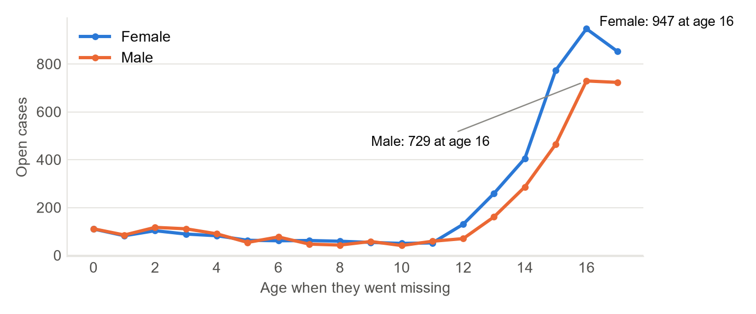
Figure 1. Open child cases by age at disappearance and sex. [1], [2], [7]

2. Who goes missing depends on the situation
In outdoor and water cases, 71% of the children are boys. Possible foul play leans female (65%). [7]
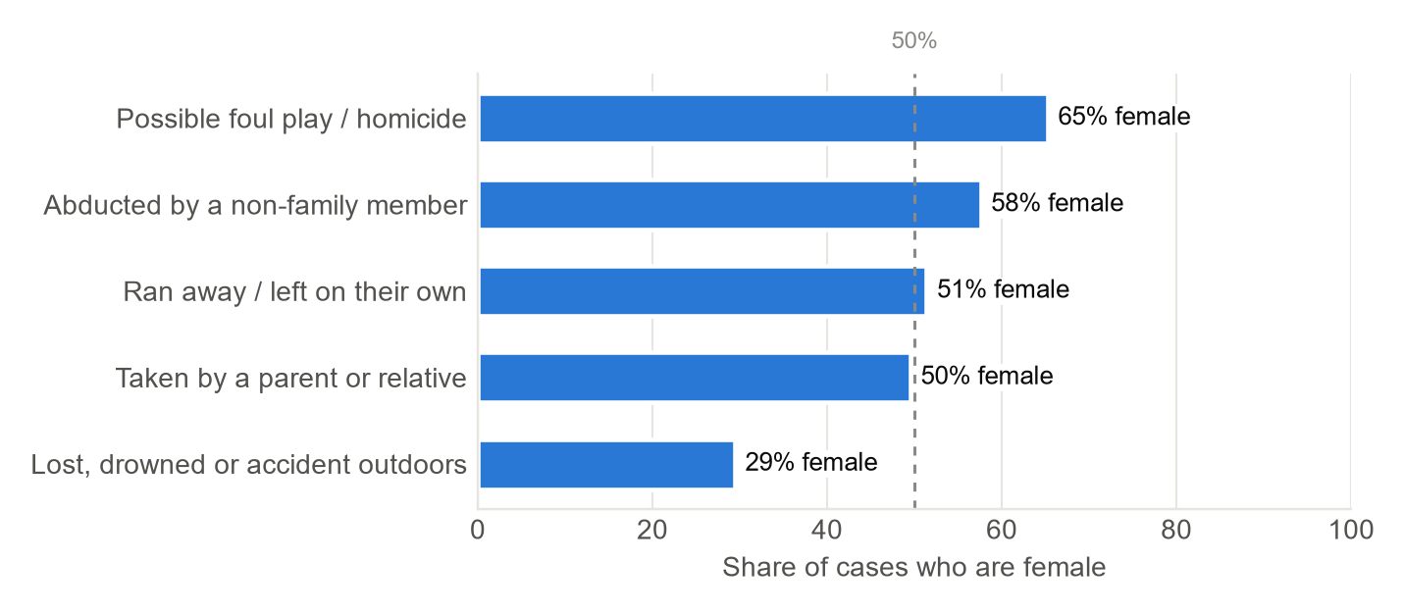
Figure 2. Share of child cases who are girls, by how they went missing (categories with 10 or more cases). [7]

3. Black, Hispanic and American Indian / Alaska Native children are over-represented
Among open child cases since 2016 with race or ethnicity recorded (4,236), 32.2% are Black children, who are 13.9% of Americans aged 0 to 17: 2.3x their population share. The ratio is 1.6x for Hispanic and 2.1x for American Indian and Alaska Native children; White (0.5x) and Asian (0.2x) children are under-represented. [7], [8]
The pattern holds in each database (Black children: 28% of NamUs and 38% of NCMEC cases) and is not explained by migration: 38 of 1,793 Hispanic child cases (2%) mention a border crossing, migrants or unaccompanied minors. This shows who is in the open-case listings, not who is most likely to go missing; differences in how quickly cases are resolved, reported and publicized could all play a part. [7]
Checked against where cases come from. Cases are concentrated in a few states whose populations differ from the nation’s, so each group was also compared with the population of the states its cases come from (each state weighted by its share of cases). Black children stay at 2.3x, Hispanic children fall to 1.4x and American Indian / Alaska Native children to 1.9x: geography explains a little of the gap, not most of it. [7], [8]
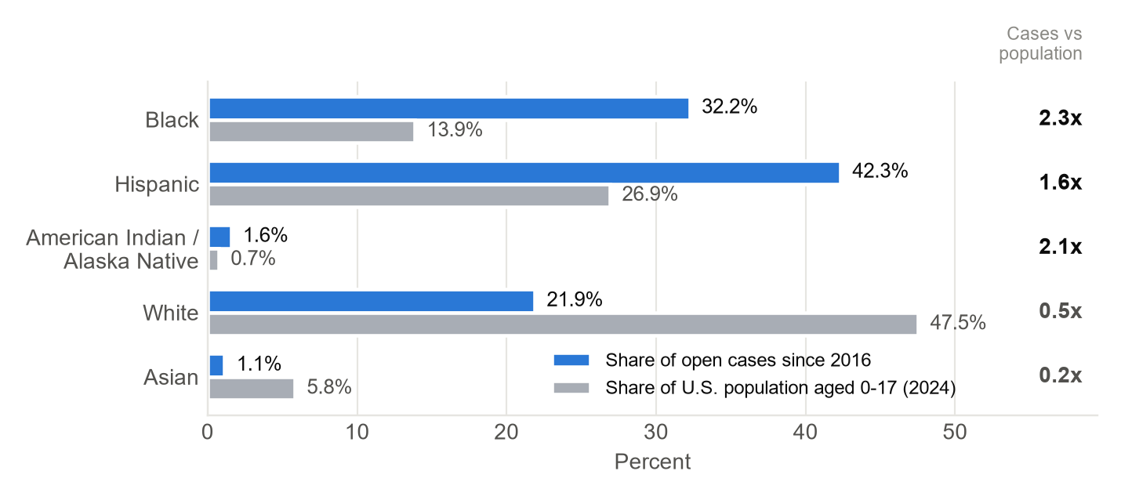
Figure 3. Share of open child cases since 2016 (known race/ethnicity) and of U.S. population aged 0 to 17 (2024). Hispanic is any race; other groups are non-Hispanic. [1], [2], [7], [8]

4. Runaway cases close quickly; abductions and suspected homicides stay open for decades
Among open child cases, the typical runaway went missing 3.0 years ago; a family abduction 16 years, an outdoor or water case 32, a non-family abduction 40 and possible foul play 41. 38% of NCMEC’s open child posters are under a year old; the median NamUs child case is 9 years old. [7], [4]
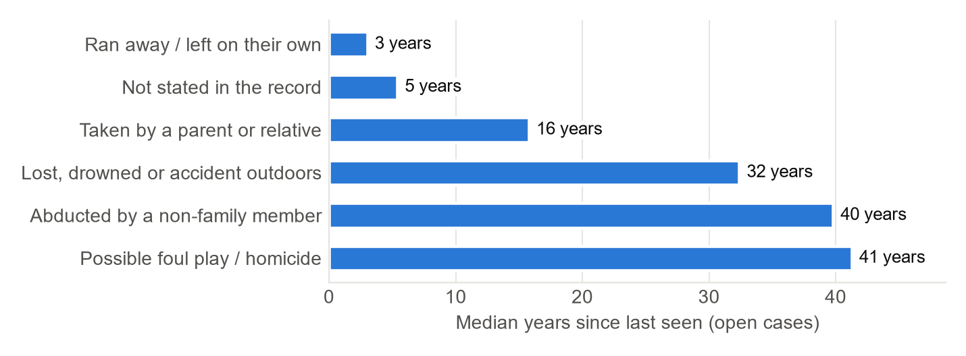
Figure 4. Median years since last seen, open child cases, by how they went missing. [7]

5. Disappearances rise in late spring and summer
Adjusted for month length, July has the most child disappearances per day and February the fewest: about 53% more per day. Cases from the last 12 months and dates recorded as January 1 are left out. [7]
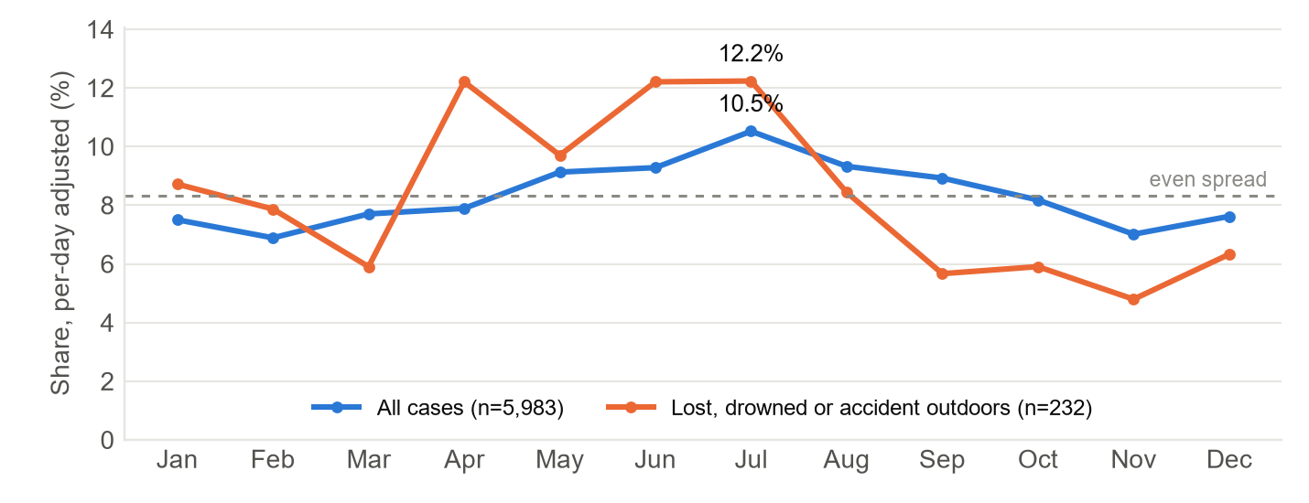
Figure 5. Share of child cases by month of disappearance, adjusted for month length (cases per day); the dashed line is an even spread (8.3%). [7]

6. When a parent takes a child, it is often across a border
219 of 525 family abductions (42%) name a foreign country. Mexico is named most often (107 cases), followed by India (16), Japan (13), Russia (10). [7]
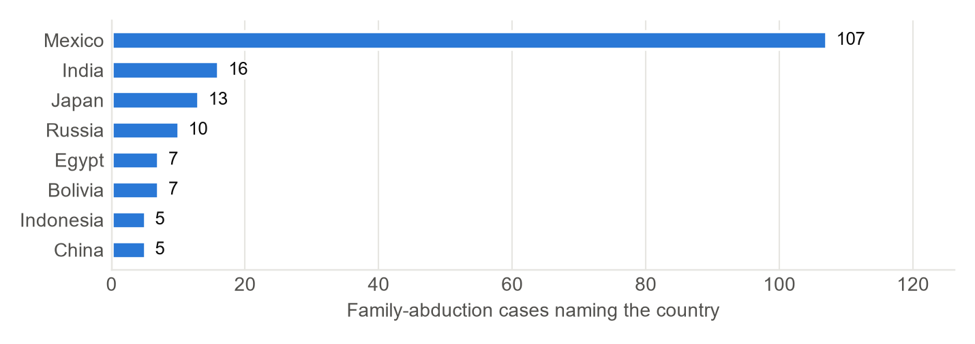
Figure 6. Countries named in family-abduction records (a case can name more than one). [1], [2], [7]

7. Phones and social media now show up in the records
Before 2000, 0.1% of child case accounts mention a phone, texts, social media or online activity; since 2010, 3%. When they appear, they often place the child somewhere after the last sighting. [7]
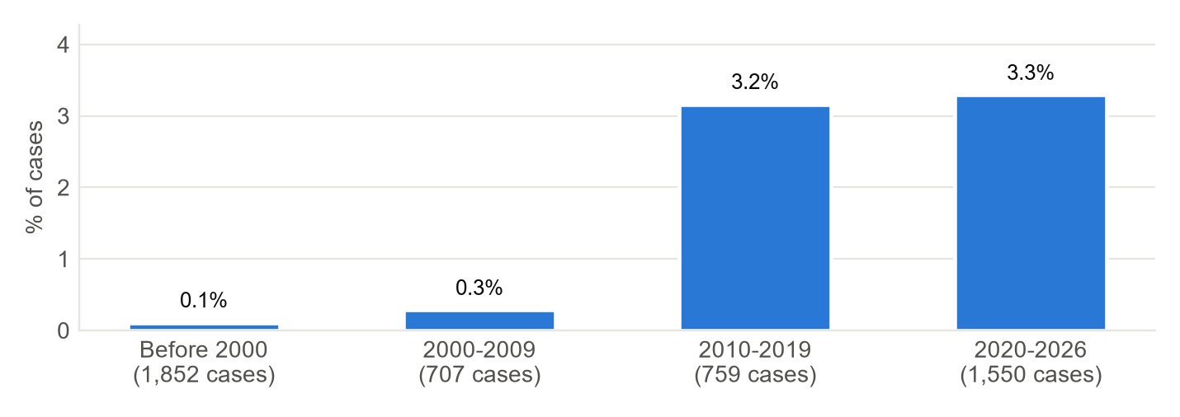
Figure 7. Share of child case accounts (more than one line) mentioning a phone, texts, social media or online activity, by year last seen. [7]

8. State rates mostly reflect reporting practices
Since 2016, the national rate is 5.8 open child cases per 100,000 children, but states differ widely. The highest rates come from states that post many cases to one database: Virginia’s are mostly NCMEC posters (325 of 356) and Tennessee’s mostly NamUs records (350 of 388). These are not risk rates. [7], [8]
State | Open cases since 2016 | Per 100,000 aged 0-17 | From NamUs / NCMEC
Tennessee | 388 | 24.5 | 350 / 38
Virginia | 356 | 18.9 | 31 / 325
Oklahoma | 134 | 13.9 | 112 / 22
Florida | 577 | 12.8 | 482 / 95
Texas | 689 | 9.0 | 536 / 153
Alaska | 15 | 8.6 | 13 / 2
Arizona | 135 | 8.5 | 46 / 89
Hawaii | 20 | 6.8 | 7 / 13
Vermont | 1 | 0.9 | 0 / 1
Maine | 2 | 0.8 | 1 / 1
Iowa | 5 | 0.7 | 2 / 3
North Dakota | 1 | 0.5 | 0 / 1
Delaware | 1 | 0.5 | 0 / 1
Top 8 and bottom 5 states. [7], [8]

9. Nationally, a small slow group makes up half of active juvenile records
FBI figures for 2015–2025 (2021 not published online) give the number of juvenile records entered each year and the number still active on December 31. Juvenile records stay open 24–31 days on average. A stock-and-flow model (the linear form of the predator-prey idea) fits a fast group that closes in about 13 days and a slow group of about 0.8% of records with a half-life of about 2.9 years. That slow group is 49%–53% of active juvenile records in every year. [9], [7]
The model explains the structure but does not forecast better than simple rules: one year ahead, “same as last year” missed by 7.8% on average and the model by 11.8%. Active juvenile records fell 13% in 2024 and 16% in 2025, faster than entries; something in how records close changed, and the yearly totals cannot say what. [9], [7]
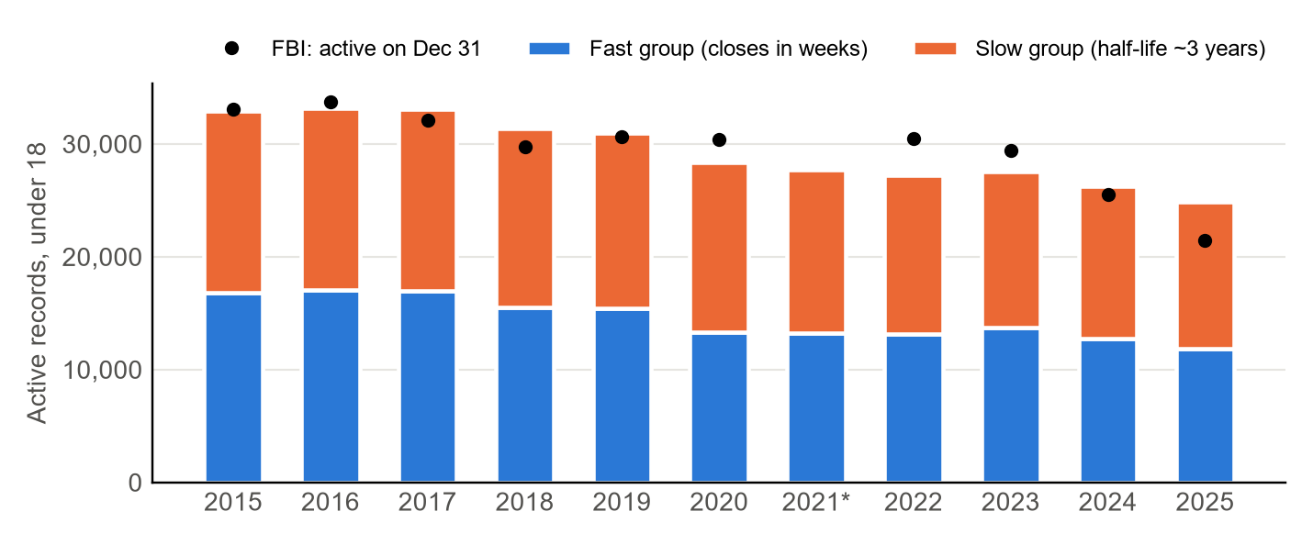
Figure 8. Active juvenile (under 18) NCIC records on December 31 (dots) and the model’s fast and slow groups (bars). *2021 entries interpolated. [9], [7]

10. Smaller patterns
- Missing together: 218 of 3,048 NCMEC children (7%) went missing with a sibling or another child. [2], [7]
- Foster care and group homes: 93 teen records mention foster care, a group home, a shelter or a state placement, including 47 of 570 teen runaway cases (8%); a minimum, since most records don’t say where the teen lived. [7]

Example cases: children
Short summaries of real records, identified by public case number, not name. Each links to the official record. [1], [2]
Case | Age, year, state | What the record says | Category
NamUs MP4571 | 16, 1979, CA | Walking back to her grandmother’s house after a church youth meeting. Two men later confessed to abducting her. | Non-family abduction
NamUs MP6704 | Infant, 1993, GA | Taken from his hospital room. | Non-family abduction
NamUs MP19556 | 4, 2005, CA | Allegedly taken by her mother; a federal flight warrant was issued and she is believed to be abroad. | Family abduction
NamUs MP98717 | 9, 2020, OR | Taken from his home between 6 and 8 a.m.; may be with non-custodial family. | Family abduction
NamUs MP103596 | 16, 2018, UT | Packed her belongings and left home; later leads pointed to two other states. | Ran away
NamUs MP100826 | 14, 2023, IL | Described as a habitual runaway; social media posts later placed her on a Chicago train line. | Ran away
NamUs MP95886 | 17, 2022, VA | Ran away while at work. | Ran away
NamUs MP66559 | 13, 2004, AK | Playing in a kayak with another boy; his shoes were later found in the overturned kayak. Presumed drowned. | Outdoors / water
NamUs MP8746 | 16, 2010, MI | Went outside to make a phone call and never came back; two men were later charged in her death. | Possible foul play
NCMEC NCMC-1107030 | 2, 2008, MI | Last seen at a gas station around 9 p.m. | Not stated
NamUs MP80827 | 17, 2021, TX | Last seen at her sister’s apartment; social media activity appeared near another city weeks later. | Not stated
Summaries paraphrase the official record as of the collection date. Records can change as investigations go on. [1], [2]

Before and after the last sighting: children
- Before: 107 children have an earlier event in their record (27 mention a history of running away). [7]
- After the last sighting: 1,433 children have later details: sightings and “may be traveling to” leads (1,260), or a car or belongings found (89). [7]
- Found: Neither database publishes outcomes; a case drops off when the child is located. Weekly collection since 2026-10-21 has recorded 138 children found so far. [1], [2], [7]
- Found quickly, or not for years: Of NCMEC child cases listed on 2026-10-22, 23% of those open 30 days or less were found within 3 days, against 7% of those open 31–90 days, 1% at 3–12 months and 0% of those open over 5 years. It is one short window, but it shows the same fast and slow groups as the national model. [2], [7]

Part 2: Young adults (18–25)
These 4,728 open cases are kept apart from the children in Part 1 and compared with the population aged 18 to 25. They are context for the children’s figures, not part of them. [7], [8]

How young adults went missing
How they went missing | Cases | Share
Not stated in the record | 4,046 | 86%
Lost, drowned or accident outdoors | 387 | 8%
Possible foul play / homicide | 230 | 5%
Ran away / left on their own | 42 | 1%
Abducted by a non-family member | 23 | 0%

Places and activities
How they went missing | Cases | Share
Not stated in the record | 4,046 | 86%
Lost, drowned or accident outdoors | 387 | 8%
Possible foul play / homicide | 230 | 5%
Ran away / left on their own | 42 | 1%
Abducted by a non-family member | 23 | 0%

Places mentioned | Cases | Share
Home / family residence | 1,135 | 24%
Vehicle / transit | 756 | 16%
Street / walking / bus | 631 | 13%
Park / outdoors / water | 529 | 11%
Workplace | 231 | 5%
Store / mall / restaurant | 221 | 5%

Activities mentioned | Cases | Share
Visiting friend / boyfriend / girlfriend | 384 | 8%
Walking / on foot | 313 | 7%
Left home (often after argument / at night) | 231 | 5%
Driving / riding in a vehicle | 216 | 5%
Party / night out | 179 | 4%
Swimming / hiking / outdoors | 170 | 4%

2,650 of 4,728 cases in this group (56%) mention any place or activity. Shares are out of all cases in the group. [7]

Insights about young adults
Mostly men. 60% of open young-adult cases are men; the peak age is 24. [7]
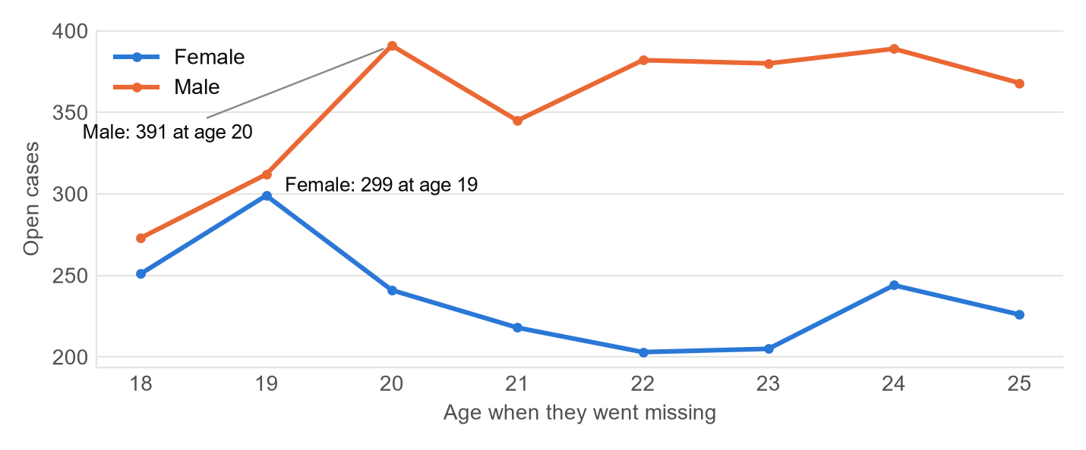
Figure 9. Open young-adult cases by age at disappearance and sex. [1], [2], [7]
Outdoor, water and foul-play cases are a larger share than among children. Outdoor and water cases are 8% of young-adult cases and 83% of them are men; possible foul play is 5%. [7]
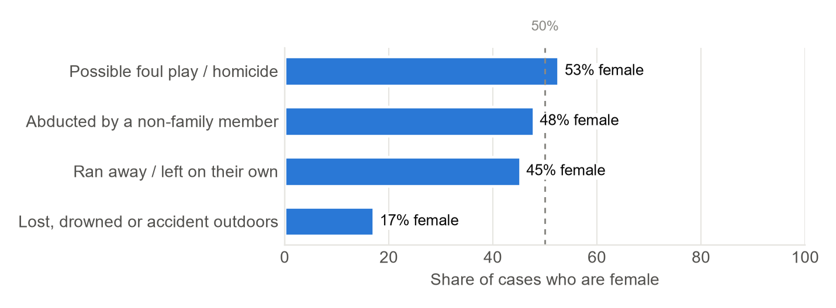
Figure 10. Share of young-adult cases who are women, by how they went missing (10 or more cases). [7]
American Indian and Alaska Native young adults are the most over-represented group in this report. They appear in open cases since 2016 at 4.7x their share of Americans aged 18 to 25 (children: 2.1x). Black (1.7x) and Hispanic (1.4x) young adults are also over-represented. Much of the American Indian / Alaska Native gap is geography: against the population of the states the cases come from, it is 2.4x, and Hispanic young adults are 1.2x; Black young adults stay at 1.8x. [7], [8]
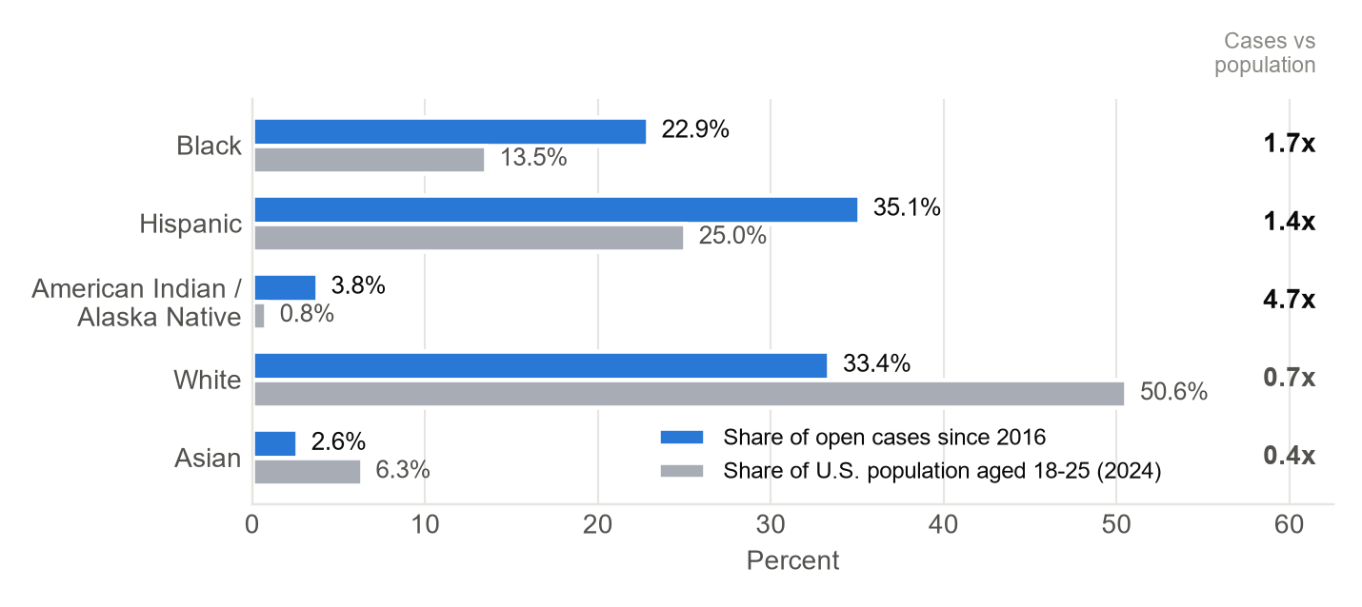
Figure 11. Share of open young-adult cases since 2016 and of U.S. population aged 18 to 25 (2024). Hispanic is any race; other groups are non-Hispanic. [1], [2], [7], [8]
Open cases are older. Open young-adult runaway cases are typically 8 years old (children: 3.0); cases with no stated cause, 23 years (children: 5). [7]
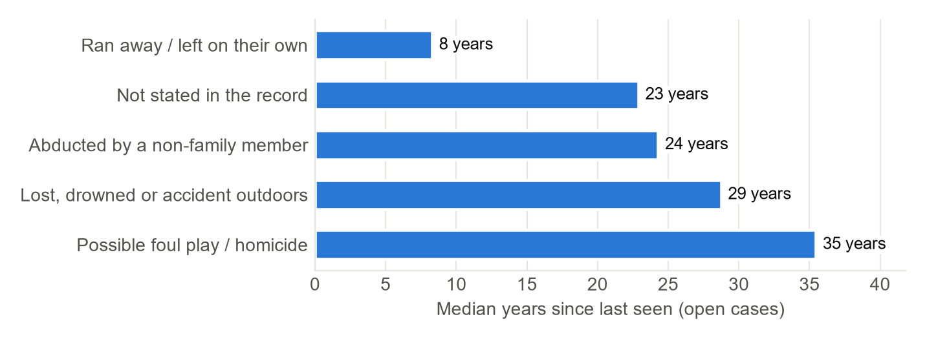
Figure 12. Median years since last seen, open young-adult cases, by how they went missing. [7]
Seasonality. Adjusted for month length, June has the most young-adult disappearances per day and December the fewest: about 40% more per day. [7]
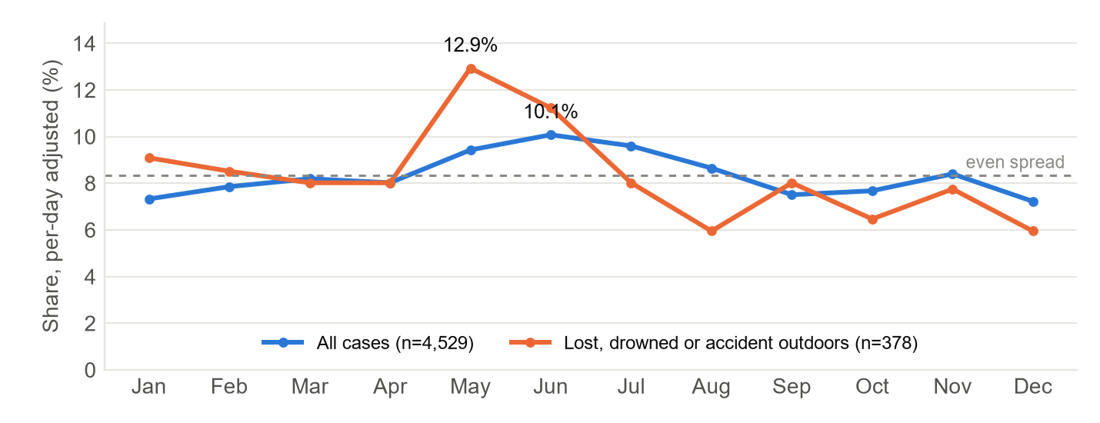
Figure 13. Share of young-adult cases by month of disappearance, adjusted for month length. [7]
State rates. The national rate is 3.3 open young-adult cases per 100,000 people aged 18 to 25 since 2016; as for children, state differences mostly reflect reporting. [7], [8]
State | Open cases since 2016 | Per 100,000 aged 18-25 | From NamUs / NCMEC
Alaska | 34 | 49.6 | 34 / 0
Hawaii | 19 | 16.0 | 19 / 0
Oklahoma | 40 | 8.8 | 39 / 1
Texas | 258 | 7.4 | 255 / 3
Tennessee | 53 | 7.2 | 53 / 0
Montana | 8 | 6.9 | 8 / 0
New Mexico | 13 | 5.7 | 11 / 2
Arizona | 40 | 4.8 | 40 / 0
Utah | 3 | 0.6 | 3 / 0
Minnesota | 3 | 0.5 | 3 / 0
Maine | 0 | 0.0 | 0 / 0
Vermont | 0 | 0.0 | 0 / 0
Wyoming | 0 | 0.0 | 0 / 0
Top 8 and bottom 5 states. [7], [8]

Example cases: young adults
Case | Age, year, state | What the record says | Category
NamUs MP8554 | 21, 1984, TX | Disappeared from her workplace in the late afternoon; last seen talking with two men outside. | Non-family abduction
NamUs MP124303 | 25, 1998, CA | Jumped into a river during a rafting trip and was swept away. | Outdoors / water
NamUs MP9439 | 22, 1998, AZ | Left home around 7 p.m.; his car was later found empty in another city. | Possible foul play
Summaries paraphrase the official record as of the collection date. Records can change as investigations go on. [1], [2]
Before and after the last sighting. 153 young adults have an earlier event in their record and 841 have later details. [7]

Limitations
- Children and young adults are analyzed separately; no figure pools them. Three records with no age, or an age range that straddles 18, are in neither group.
- Categories come from matching keywords in each case’s written account. Samples were checked by hand, but some cases will be misclassified, especially in the smaller categories.
- Most records are short: 79% of child cases don’t say how the child went missing, so the shares for known categories are minimums.
- Only open cases are included. Runaways who return within days are under-represented, and long-unsolved cases are over-represented compared with all missing-person reports.
- NamUs and NCMEC overlap only partly; children listed in both were merged only when NCMEC recorded the NamUs case number.
- Population comparisons set open cases since 2016 against 2024 estimates of the same ages. Case records rarely record more than one race, so “two or more races” is under-counted.
- The national stock-and-flow model uses ten yearly FBI totals; it identifies one slow group but does not forecast better than “same as last year”. The FBI counts juveniles as under 18, as reported.

Method
Open cases were downloaded through the public data feeds behind NamUs and NCMEC search pages, weekly since 2026-10-21. Each person is labeled child (under 18 for the whole recorded age range), young adult (18–25) or unknown, and every analysis runs separately for children and young adults. Each case’s written account was checked against keyword lists for how the person went missing, the place and the activity; NCMEC’s official case type was used where available. Population comparisons use Census Bureau estimates for the same ages. The national model fits yearly FBI NCIC juvenile entries and active records with a fast group and a slow group, and is backtested one year ahead. [7], [8], [9]

Sources
[1] NamUs (National Missing and Unidentified Persons System), U.S. Department of Justice, National Institute of Justice. Missing Persons search and public case records. https://www.namus.gov/MissingPersons/Search Accessed October 25, 2026.
[2] National Center for Missing & Exploited Children (NCMEC). Public missing-child poster search. https://www.missingkids.org/gethelpnow/search Accessed October 25, 2026.
[3] FBI Criminal Justice Information Services. 2023 NCIC Missing Person and Unidentified Person Statistics (published Feb. 7, 2024). https://le.fbi.gov/file-repository/2023-ncic-missing-person-and-unidentified-person-statistics.pdf
[4] NCMEC. “NCMEC Releases New Data: 2024 in Numbers.” May 8, 2025. https://www.missingkids.org/blog/2025/ncmec-releases-new-data-2024-in-numbers
[5] NCMEC. “They’re Missing Too: Why Runaway Children Need Our Help.” Nov. 6, 2025. https://www.missingkids.org/blog/2025/theyre-missing-too-why-runaway-children-need-our-help
[6] NCMEC. “Non-family Abductions & Attempts.” https://www.missingkids.org/theissues/nonfamily Accessed October 25, 2026.
[7] This project’s analysis of sources [1] and [2] (and [8], [9]): collect.py (weekly collection), circumstances.py (classification), insights.py (insights, children and young adults separately), models/stock_flow_ncic.py (national model), output/*.csv, report/insights.json. Latest collection October 25, 2026.
[8] U.S. Census Bureau, Population Estimates Program, Vintage 2024. State population estimates by single year of age and sex (file SC-EST2024-AGESEX-CIV, civilian population) and by age, sex, race and Hispanic origin (file SC-EST2024-ALLDATA6), 2024 estimates. https://www2.census.gov/programs-surveys/popest/datasets/2020-2024/state/asrh/ Accessed October 22, 2026.
[9] FBI Criminal Justice Information Services. NCIC Missing Person and Unidentified Person Statistics, yearly editions 2015–2020 and 2022–2025 (2021 not found online). Juvenile entries and active records compiled in models/ncic_juvenile_by_year.csv. https://www.fbi.gov/file-repository/2025-ncic-missing-person-and-unidentified-person-statistics.pdf/view Accessed October 22, 2026.

If you have information about a missing child, contact the agency listed on the case record or NCMEC at 1-800-THE-LOST (1-800-843-5678).

